**STUDENT NAME : SHOAB AHMED**

**STUDENT ID : BC230429784**

**ASSIGNMENT CS604P**

**Question 1**

**Output:**

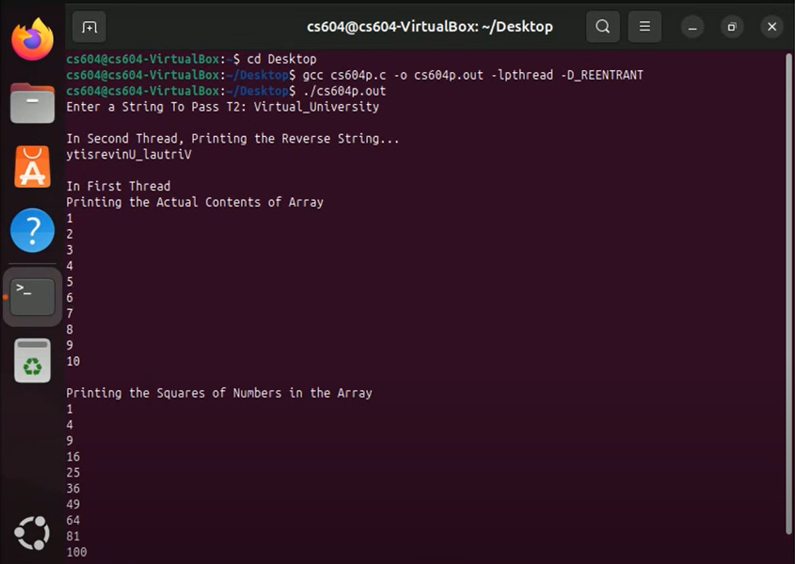

#include <stdio.h>

#include <pthread.h>

#include <string.h>

void* calculate_squares(void* param) {

int* arr = (int*)param;

printf("\nIn First Thread\nPrinting the Actual Contents of Array\n");

for (int i = 0; i < 10; i++) {

printf("%d\n", arr[i]);

}

printf("\nPrinting the squares of Numbers in the Array\n");

for (int i = 0; i < 10; i++) {

printf("%d\n", arr[i] * arr[i]);

}

printf("\n");

return NULL;

}

void* reverse_string(void* param) {

char* str = (char*)param;

int len = strlen(str);

char reversed[len + 1];

for (int i = 0; i < len; i++) {

reversed[i] = str[len - i - 1];

}

reversed[len] = '\0';

printf("\nIn Second Thread, Printing the Reverse String...\n%s\n", reversed);

return NULL;

}

int main() {

pthread_t t1, t2;

int array[10] = {1, 2, 3, 4, 5, 6, 7, 8, 9, 10};

char str[100];

printf("Enter a String To Pass T2: ");

scanf("%99s", str);

if (pthread_create(&t2, NULL, reverse_string, (void*)str) != 0) {

perror("Failed to Create Thread T2");

return 1;

}

if (pthread_create(&t1, NULL, calculate_squares, (void*)array) != 0) {

perror("Failed to Create Thread T1");

return 1;

}

pthread_join(t2, NULL);

pthread_join(t1, NULL);

return 0;

}